实验八 导航和布局

【实验目的】
- 掌握HTML和 CSS布局和导航。
- 掌握主要编程工具Notepad++、sublime。
- 掌握主要浏览器Firefox、Chrome

【实验学时】
建议2学时

【实验环境配置】
- firefox浏览器环境
- Notepad++、Sublime

【实验原理】
HTML和CSS布局和导航

【实验步骤】
- 使用标签 div实现以下布局：
试着在firefox浏览器实现下图的效果：
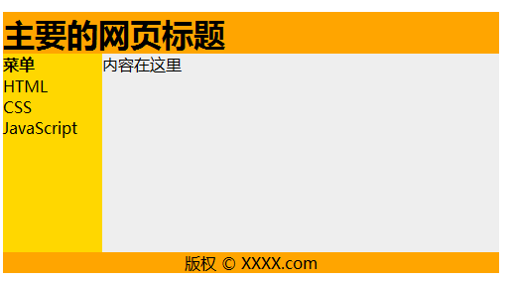
- 使用 table 实现以下布局：
试着在firefox浏览器实现下图的效果：
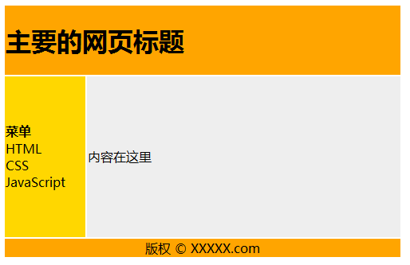
- 使用 CSS3的响应式网格视图实现以下布局：
试着在firefox浏览器实现下图的效果：
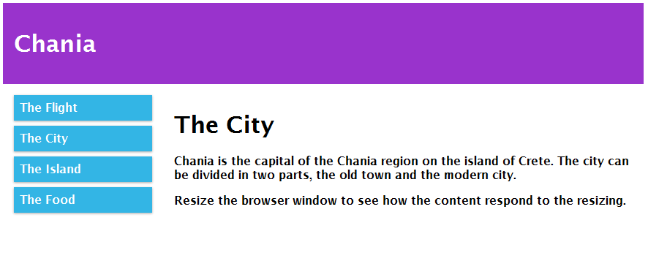
提示：
* {
box-sizing: border-box;
}
.row:after {
content: "";
clear: both;
display: block;
}
[class*="col-"] {
float: left;
padding: 15px;
}
.col-1 {width: 8.33%;}
.col-2 {width: 16.66%;}
.col-3 {width: 25%;}
.col-4 {width: 33.33%;}
.col-5 {width: 41.66%;}
.col-6 {width: 50%;}
.col-7 {width: 58.33%;}
.col-8 {width: 66.66%;}
.col-9 {width: 75%;}
.col-10 {width: 83.33%;}
.col-11 {width: 91.66%;}
.col-12 {width: 100%;}
body {
font-family: "Lucida Sans", sans-serif;
}
.header {
background-color: #9933cc;
color: #ffffff;
padding: 15px;
}
.menu ul {
list-style-type: none;
margin: 0;
padding: 0;
}
.menu li {
padding: 8px;
margin-bottom: 7px;
background-color :#33b5e5;
color: #ffffff;
box-shadow: 0 1px 3px rgba(0,0,0,0.12), 0 1px 2px rgba(0,0,0,0.24);
}
.menu li:hover {
background-color: #0099cc;
}
- 使用 CSS实现垂直导航栏
试着在firefox浏览器实现下图的效果:


- 使用 CSS实现水平导航栏
试着在firefox浏览器实现下图的效果:

提示：
li
{
float:left;
}
a
{
display:block;
}
- 使用 CSS实现胶囊式水平导航栏
试着在firefox浏览器实现下图的效果:

提示：
li
{
display:inline;
}

【结果显示】
第一题：
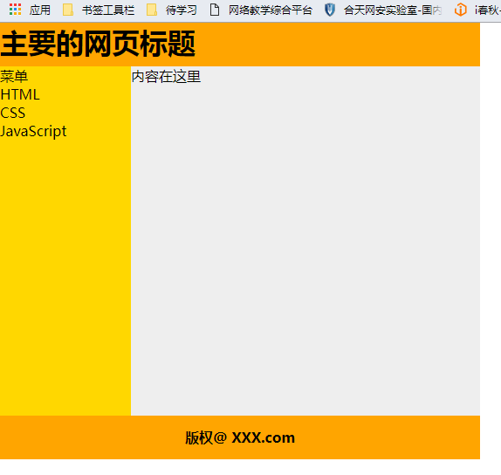
<!DOCTYPE html>
<html lang="en">
<head>
<meta charset="UTF-8">
<title>Title</title>
<style>
*{
margin: 0;
padding: 0;
}
.header{
background: #FFA500;
width: 550px;
height:50px;
}
.left{
float: left;
background: #FFD700;
width: 150px;
height: 400px;
}
.left li{
list-style: none;
}
.right{
float: left;
width: 400px;
height: 400px;
background: #EEEEEE;
}
.footer{
background: #FFA500;
width: 550px;
line-height: 50px;
height: 50px;
clear: both;
font-weight: bold;
text-align: center;
}
</style>
</head>
<body>
<div class="wrapper">
<div class="header">
<h1>主要的网页标题</h1>
</div>
<div class="left">
<ul>
<li>菜单</li>
<li>HTML</li>
<li>CSS</li>
<li>JavaScript</li>
</ul></div>
<div class="right">
内容在这里
</div>
<div class="footer">
版权@ XXX.com
</div>
</div>
</body>
</html>

第二题:
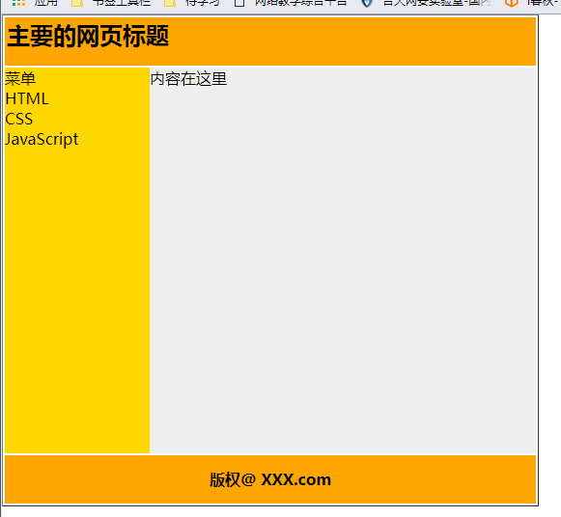
<!DOCTYPE html>
<html lang="en">
<head>
<meta charset="UTF-8">
<title>Title</title>
<style>
th{
border: 0;
}
td{
border: 0;
}
*{
margin: 0;
padding: 0;
}
li{
list-style: none;
}
table tr:nth-of-type(1){
display: block;
background: #FFA500;
width: 550px;
height:50px;
}
.left{
display: block;
float: left;
background: #FFD700;
width: 150px;
height: 400px;
}
table td:nth-of-type(2){
display: block;
height: 400px;
background: #EEEEEE;
}
.footer{
background: #FFA500;
width: 550px;
line-height: 50px;
height: 50px;
clear: both;
font-weight: bold;
text-align: center;
}
</style>
</head>
<body>
<table border="1">
<tr>
<th colspan="2"><h2>主要的网页标题</h2></th>
</tr>
<tr>
<td class="left">
<ul>
<li>菜单</li>
<li>HTML</li>
<li>CSS</li>
<li>JavaScript</li>
</ul>
</td>
<td>
内容在这里
</td>
</tr>
<tr class="footer">
<td>版权@ XXX.com</td>
</tr>
</table>
</body>
</html>

第三题:
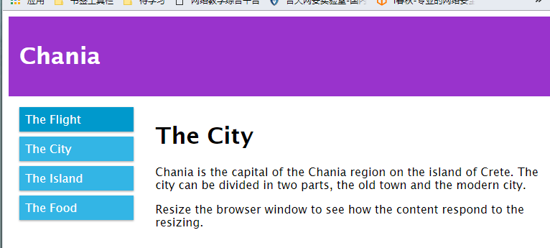
<!DOCTYPE html>
<html>
<head>
<meta name="viewport" content="width=device-width, initial-scale=1.0">
<meta charset="utf-8">
<title>Title</title>
<style>
* {
box-sizing: border-box;
}
.row:after {
content: "";
clear: both;
display: block;
}
[class*="col-"] {
float: left;
padding: 15px;
}
.col-1 {width: 8.33%;}
.col-2 {width: 16.66%;}
.col-3 {width: 25%;}
.col-4 {width: 33.33%;}
.col-5 {width: 41.66%;}
.col-6 {width: 50%;}
.col-7 {width: 58.33%;}
.col-8 {width: 66.66%;}
.col-9 {width: 75%;}
.col-10 {width: 83.33%;}
.col-11 {width: 91.66%;}
.col-12 {width: 100%;}
html {
font-family: "Lucida Sans", sans-serif;
}
.header {
background-color: #9933cc;
color: #ffffff;
padding: 15px;
}
.menu ul {
list-style-type: none;
margin: 0;
padding: 0;
}
.menu li {
padding: 8px;
margin-bottom: 7px;
background-color :#33b5e5;
color: #ffffff;
box-shadow: 0 1px 3px rgba(0,0,0,0.12), 0 1px 2px rgba(0,0,0,0.24);
}
.menu li:hover {
background-color: #0099cc;
}
</style>
</head>
<body>

<div class="header">
<h1>Chania</h1>
</div>

<div class="row">

<div class="col-3 menu">
<ul>
<li>The Flight</li>
<li>The City</li>
<li>The Island</li>
<li>The Food</li>
</ul>
</div>

<div class="col-9">
<h1>The City</h1>
<p>Chania is the capital of the Chania region on the island of Crete. The city can be divided in two parts, the old town and the modern city.</p>
<p>Resize the browser window to see how the content respond to the resizing.</p>
</div>

</div>
</body>
</html>

第四题:
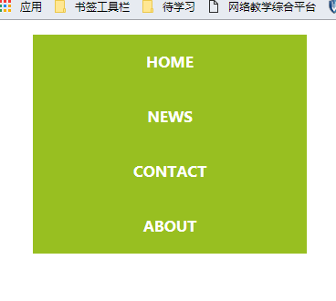
<!DOCTYPE html>
<html lang="en">
<head>
<meta charset="UTF-8">
<title>Title</title>
<style>
li{
list-style: none;
width: 300px;
height: 60px;
background: #98BF21;
text-align: center;
}
li a{
font-weight: bold;
text-decoration: none;
line-height: 60px;
color: #FFFFFF;
}
</style>
</head>
<body>
<ul>
<li><a href="">HOME</a></li>
<li><a href="">NEWS</a></li>
<li><a href="">CONTACT</a></li>
<li><a href="">ABOUT</a></li>
</ul>
</body>
</html>

第五题:

<!DOCTYPE html>
<html lang="en">
<head>
<meta charset="UTF-8">
<title>Title</title>
<style>
li{
list-style: none;
width: 150px;
height: 30px;
background: #98BF21;
text-align: center;
float: left;
}
li a{
font-weight: bold;
text-decoration: none;
line-height: 30px;
color: #FFFFFF;
}
</style>
</head>
<body>
<ul>
<li><a href="">HOME</a></li>
<li><a href="">NEWS</a></li>
<li><a href="">CONTACT</a></li>
<li><a href="">ABOUT</a></li>
</ul>
</body>
</html>

第六题:

<!DOCTYPE html>
<html lang="en">
<head>
<meta charset="UTF-8">
<title>Title</title>
<style>
li{
list-style: none;
width: 150px;
height: 30px;
background: #98BF21;
text-align: center;
float: left;
margin-right: 10px;
}
li a{
font-weight: bold;
text-decoration: none;
line-height: 30px;
color: #FFFFFF;
}
</style>
</head>
<body>
<ul>
<li><a href="">HOME</a></li>
<li><a href="">NEWS</a></li>
<li><a href="">CONTACT</a></li>
<li><a href="">ABOUT</a></li>
</ul>
</body>
</html>

